TOOLS AND SIMULATION

Exploring Open-Source Network Protocol Analysis using Wireshark (HTTP)
Demonstration of HTTP Data Exposure using Wireshark and Comparison with HTTPS Encryption

Submitted by:
Name: Akshita Pardeshi
Roll No: 18
Branch / Semester: CSE / III
Batch: B2
Name: Tejal Bhagat
Roll No: 63
Branch / Semester: CSE / III
Batch: B4
Name: Harshita Agrawal
Roll No: 16
Branch / Semester: CSE / III
Batch: B1

1. Aim / Objective
To demonstrate how unencrypted HTTP transmits login credentials in plain text, allowing them to be intercepted using Wireshark, and to compare it with HTTPS, which encrypts the data to ensure secure communication.

2. Theory / Conceptual Background
HTTP (Hypertext Transfer Protocol) is an application-layer protocol used for transmitting web data in plain text. It does not encrypt the transmitted information, meaning anyone capturing the network traffic can read the contents, including usernames and passwords.
HTTPS (Hypertext Transfer Protocol Secure) adds a security layer using SSL/TLS encryption, ensuring that the communication between the client and server is private and cannot be easily intercepted.

Key Concepts:
- Plain Text Transmission: Data sent via HTTP can be directly viewed in packet analyzers like Wireshark.
- Encryption: HTTPS encrypts requests and responses, making the data unreadable to third parties.
- Wireshark: A network protocol analyzer used to capture and inspect network packets in real time.
- POST Method: Used to send data (e.g., login details) to a server in the HTTP body — unencrypted in HTTP but encrypted in HTTPS.
Underlying Principle:
HTTP communication follows this structure:
POST /login HTTP/1.1
Host: localhost:9090
Content-Type: application/x-www-form-urlencoded
user=alice&pass=wonderland123

In HTTPS, the above data is encrypted during transmission, ensuring confidentiality and integrity.
3. Software / Simulation Tool Used
- Simulation Tool: Wireshark v4.2.0
- Programming Language: Python 3.13
- Web Browser: Chrome / Edge
- Optional Framework (for HTTPS demo): Flask (Python Web Framework)

4. Hardware / Software Requirements
Hardware:
- Processor: Intel i5 or above
- RAM: 8 GB or above
- Storage: 1 GB free disk space
Software:
- Operating System: Windows 10 / 11
- Python 3.x
- Wireshark (latest version)
- Browser (Chrome / Edge)
5. Procedure / Steps Performed

- Step 1: Create a working directory
- Step 2: Create a simple login form (login.html)
- Step 3: Create a minimal Python HTTP server (server.py)
- Step 4: Run the server
- Step 5: Open Wireshark
- Step 6: Visit the login form
- Step 7: Stop Capture and Apply Filter
- Step 8: Inspect Packet Details
Open:
https://localhost:9090
Notice that data is encrypted and unreadable.

6. Simulation Diagram / Screenshot

Block Diagram :

The following screenshots show the results of capturing HTTP packets using Wireshark. The experiment demonstrates how login credentials can be intercepted when transmitted through an unencrypted HTTP connection.
Figure 1: HTTP Login Page (localhost) Observation: The login form transmits credentials through HTTP, which does not provide encryption.
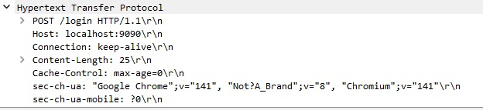
Figure 2: Captured HTTP POST Request in Wireshark Observation: Wireshark captures an HTTP POST request showing transmission of form data.
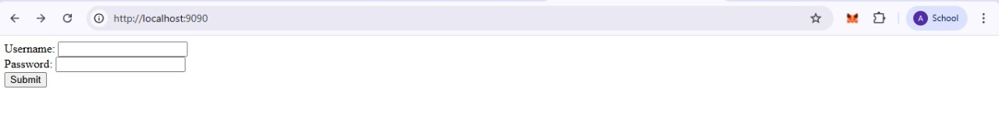
Figure 3: Decoded HTTP Form Data Observation: The username and password fields are visible in plain text, confirming that HTTP transmits sensitive data without encryption
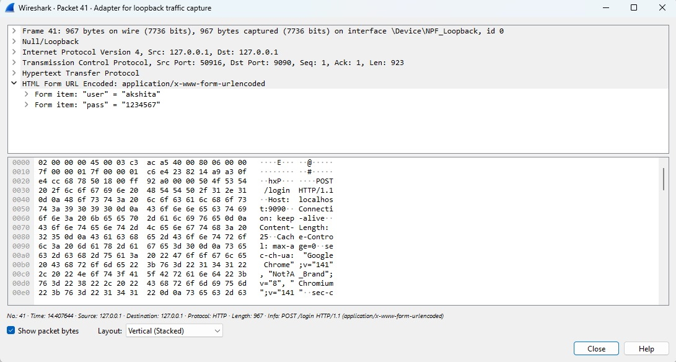

7. Observations
Protocol | Captured Data in Wireshark | Encryption | Readable Credentials
HTTP | user=alice&pass=wonderland123 | None | Yes
HTTPS | Encrypted binary data | SSL/TLS | No
This analysis highlights that HTTP traffic is insecure, as credentials and other data can be intercepted easily. HTTPS, which uses SSL/TLS encryption, prevents such data exposure by securing communication between client and server.

8. Result / Output
Successfully demonstrated that:
- HTTP transmits credentials in plain text, visible in Wireshark.
- HTTPS encrypts the transmitted data, protecting confidentiality.
This proves that HTTP is insecure for sensitive transactions, while HTTPS ensures secure communication.

9. Conclusion
The experiment highlights the importance of using HTTPS for secure web communication.
When data is sent over HTTP, it can be intercepted and read by anyone on the same network.
Using HTTPS with SSL/TLS encryption ensures that credentials and other sensitive information remain private and protected from attackers.
Real-world implication: Websites using HTTP for login forms are vulnerable to credential theft, whereas HTTPS prevents such attacks.

10. Viva Questions
- What is the difference between HTTP and HTTPS?
- How does Wireshark capture and display HTTP packets?
- Why are credentials visible in HTTP POST requests?
- What role does SSL/TLS play in HTTPS communication?
- Can attackers read HTTPS data if they capture packets? Why or why not?
- What is the purpose of the filter http.request.method == "POST" in Wireshark?
- How does HTTPS ensure confidentiality and integrity?

References:
[1] Wireshark Foundation, “Wireshark User Guide,” 2023. [Online]. Available: https://www.wireshark.org/
[2] RFC 2616, Hypertext Transfer Protocol -- HTTP/1.1, Internet Engineering Task Force (IETF). [3] S. Bradner, “The Secure Socket Layer (SSL) Protocol Version 3.0,” RFC 6101, 2011.

